#### **IoT Based Automatic Vehicle Accident**

#### **Alert System**

B.E.Major project report submitted in partial fulfilment of the requirements of the degree of

### Bachelor of Engineering (B.E.)

in

### INFORMATION TECHNOLOGY

by

| Sanika Bhanushali | [EU1204034] |
| --- | --- |
| Rohit Mule | [EU1204010] |
| Shrey Shaparia | [EU1204013] |

Under the guidance of

| **Mrs. Maya Patil** |
| --- |
| Assistant Professor |



### Department of Information Technology

**St. John College of Engineering and Management, Palghar University of Mumbai**

2023–2024

## CERTIFICATE

This is to certify that the B.E. project entitled **“IoT Based Automatic Vehicle Accident Alert System”** is a bonafide work of **“Sanika Bhanushali” (EU1204034), “Rohit Mule” (EU1204010),** and **“Shrey Shaparia” (EU1204013)** submitted to University of Mumbai in partial fulfilment of the requirement for the award of the degree of **“Bachelor of Engineering”** in **“Information Technology”** during the academic year 2023–2024.

| **Mrs. Maya Patil** |
| --- |
| Project Guide |

| **Dr. Arun Saxena** | **Dr. G.V. Mulgund** |
| --- | --- |
| Head of Department | Principal |

ii

# B.E. Project Report Approval

This project report entitled **GuardianWatch: AI-Powered Public Safety Surveillance** by ***Akshara Raul, Chinmay Dongare, Shubham Jha*** is approved for the degree of ***Bachelor of Engineering*** in ***Information Technology*** from ***University of Mumbai***.

**Examiners**

1.

2.

Date:

Place: Palghar

iii

# Declaration

We declare that this written submission represents our ideas in our own words and where others’ ideas or words have been included, we have adequately cited and referenced the original sources. We also declare that we have adhered to all principles of academic honesty and integrity and have not misrepresented or fabricated or falsified any idea/data/fact/source in our submission. We understand that any violation of the above will be cause for disciplinary action by the Institute and can also evoke penal action from the sources which have thus not been properly cited or from whom proper permission has not been taken when needed.



Signature

Sanika Bhanushali (EU1204034)



Signature

Rohit Mule (EU1204010)



Signature

Shrey Shaparia (EU1204013)

Date:

## Abstract

*The IoT-based Automatic Vehicle Accident Alert System represents a pivotal advancement in road safety technology. This system employs a network of interconnected sensors, real-time data analysis, and seamless connectivity to automatically detect and respond to vehicle accidents. When an accident occurs, the system is rapidly identifying the incident and promptly transmits an alert to emergency services. This real-time communication facilitates swift response times, potentially mitigating the severity of injuries and saving lives. The system's primary goal is to reduce accident-related fatalities and enhance overall road safety by revolutionizing accident detection and response mechanisms. This abstract provides a glimpse into a transformative solution that aims to make road travel safer all.*

## Table of Contents

|  | **Abstract** | **v** |
| --- | --- | --- |
|  | **List of Figures** | **vii** |
|  | **List of Tables** | **viii** |
|  | **List of Abbreviations** | **ix** |
| **Chapter 1** | **Introduction** | **11** |
|  | 1.1 Motivation | 11 |
|  | 1.2 Problem Statement | 12 |
|  | 1.3 Objectives | 12 |
|  | 1.4 Scope | 13 |
| **Chapter 2** | **Review of Literature** | 14 |
| **Chapter 3** | **Requirements Gathering and Planning** | **17** |
|  | 3.1 Requirement Elicitation | 17 |
|  | 3.1.1 Use case Diagram | 17 |
|  | 3.1.2 Activity Diagram | 18 |
|  | 3.1.3 Sequence Diagram | 19 |
|  | 3.2 Dataflow Diagrams (DFDs) | 20 |
|  | 3.2.1 Level 0 DFD | 20 |
|  | 3.2.2 Level 1 DFD | 20 |
|  | 3.2.3 Level 2 DFD | 21 |
|  | 3.3 Technical Feasibility | 22 |
|  | 3.3.1 Hardware Requirements | 22 |
|  | 3.3.2 Software Requirements | 22 |
|  | 3.4 Timeline/Gantt Chart | 23 |
|  | 3.5 Work Breakdown Structure (WBS) Chart | 24 |
| **Chapter 4** | **Report on Present Investigation** | **25** |
|  | 4.1 Proposed System | 25 |
|  | 4.1.1 Block diagram of Proposed System | 25 |
|  | 4.2 Implementation | 26 |
|  | 4.2.1 Algorithm/Flowchart | 26 |
|  | 4.2.3 Pseudo code | 27 |
|  | 4.2.4 Screenshots of the output with description | 29 |
| **Chapter 5** | 5.1 Technologies Used | 30 |
| **Chapter 6** | **Results and Discussion** | **36** |
| **Chapter 7** | **Conclusion and Future Work** | **37** |
|  | **References** | **38** |
|  | **Acknowledgments** | **40** |

**List of Figures**

| **Figure No.** | **Figure Name** | **Page No.** |
| --- | --- | --- |
| 3.1.1 | Use Case Diagram | 17 |
| 3.1.2 | Activity Diagram | 18 |
| 3.1.3 | Sequence Diagram | 19 |
| 3.2.1 | Level 0 DFD | 20 |
| 3.2.2 | Level 1 DFD | 20 |
| 3.2.3 | Level 2 DFD | 21 |
| 3.4 | Gantt Chart | 23 |
| 3.5 | WBS Chart | 24 |
| 4.1.1 | Block diagram | 25 |
| 4.2.1 | Flowchart | 26 |
| 4.1.3.1 | Output | 29 |

## List of Tables

| **Table No.** | **Table Name** | **Page No.** |
| --- | --- | --- |
| 3.3.1 | Hardware Requirements | 22 |
| 3.3.2 | Software Requirements | 22 |

**List of Abbreviations**

| **WBS** | Work Breakdown Structure |
| --- | --- |
| **DFD** | Dataflow Diagram |
| **SJCEM** | St. John College of Engineering and Management |
| **GB** | Giga Byte |
| **GUI** | Graphical User Interface |
| **IPFS** | Inter-Planetary File System |

**Chapter 1**

**Introduction**

The high demand of automobiles has also increased the traffic hazards and the road accidents. Life of the people is under high risk. This is because of the lack of best emergency facilities available in our country. An automatic alarm device for vehicle accidents is introduced in this paper. This design is a system which can detect accidents in significantly less time and sends the basic information to first aid center within a few seconds covering geographical coordinates, the time and angle in which a vehicle accident had occurred.

The IoT-based Automatic Vehicle Accident Alert System is a cutting-edge technology designed to swiftly identify accidents and alert authorities. By integrating sensors and GPS, it detects abrupt changes indicative of an accident and promptly notifies emergency services and contacts. This system significantly reduces response times, enhancing the chances of survival and recovery for accident victims, ultimately revolutionizing road safety.

**1.1 Motivation**

Developing an IoT-based Automatic Vehicle Accident Alert System is a highly motivating endeavor due to its potential to significantly enhance road safety and save lives. Accidents remain a leading cause of injury and death globally, and this technology can expedite emergency response, thereby reducing mortality and the severity of injuries. The adoption of emerging technologies, government support, and the opportunity to make a positive impact on society make this topic particularly compelling for researchers, engineers, and businesses. Moreover, the personal and environmental implications, as well as the potential for commercial success, further underline the importance and motivation behind pursuing such a system

In conclusion, the IoT-based Automatic Vehicle Accident Alert System is a critical innovation that can address a pressing societal issue, improve safety, and provide opportunities for technological advancement and commercialization, making it a highly motivating and impactful field of development

**1.2 Problem Statement**

Develop an IoT-based Automatic Vehicle Accident Alert System that can detect accidents using accelerometers, gyroscopes, and collision sensors, transmit real-time alerts via a secure and efficient communication protocol, track accident locations through GPS, and provide a user-friendly interface for vehicle owners while optimizing power consumption and ensuring data privacy and security. The system should seamlessly integrate with emergency services, offer backup and redundancy mechanisms, scale across various vehicle types, remain cost-effective, and adhere to relevant regulatory standards, ultimately enhancing road safety by expediting response times and improving emergency services' effectiveness in accident situations.

**1.3 Objectives**

The objectives are as follows:

* + - Safety : The primary objective of the system is to improve safety by alerting drivers, and their recently connected people.
    - It Accurately detect the accident.
    - Real-time monitoring : The system ensure immediate and reliable transmission of accident alerts.
    - Integrate precise location tracking.
    - Implement secure communication protocols to protect accident data and user information.
    - Optimize power consumption.
    - Cost-effectiveness: The system should be cost-effective, meaning that it should not be prohibitively expensive to implement and maintain, and the benefits it provides should outweigh the costs.

**1.4 Scope**

The scope of the IoT-based Automatic Vehicle Accident Alert System project encompasses the design and development of both hardware and software components. This includes the integration of sensors such as accelerometers, gyroscopes, collision sensors, heat & humidity sensor and GPS technology to accurately detect vehicle accidents and determine their precise locations. The system will employ custom software to process sensor data, trigger real-time alerts, manage communication protocols, and offer a user-friendly interface for vehicle owners. Special attention will be given to optimizing power consumption, ensuring the privacy and security of accident data through encryption and access control mechanisms, and seamless integration with emergency services. Moreover, the system will be adaptable to various vehicle types and cost-effective while adhering to relevant regulatory standards. The project aims to significantly enhance road safety by expediting accident response times and improving the overall effectiveness of emergency services in accident situations.

## Chapter 2

**Review Of Literature**

| **Sr. No.** | **Paper Title [Ref.]** | **Author names** | **Conclusion** | **Research Gaps** |
| --- | --- | --- | --- | --- |
| [1] | A survey on IoT Automatic Road accident Detection | Suraj Pratap Shubham,  Madan Kumar, Rajkishor,  Dr.Sarika Jain | These strategies used various sensors for accident detection, including accelerometers, pressure sensors, and machine learning algorithms, including neural networks, support vector machines, and classification algorithms.. | A significant research in this is need to investigate and develop accident detection systems that are robust and resilient to hardware or software failures caused by collisions. Also address the critical issue of ensuring the continued accuracy and performance of such systems, even under adverse conditions, ultimately contributing to enhanced road safety |

| [2] | Automatic Messaging System by detecting the road accident for vehicle application | M.Karthik, L.Sreevidya, K.Vinodha, M.Thangara, G.Hemalath,  T.Viswak Sena | The accident alert and detection project’s major goal is to try to minimize the number of people who die in accidents.Whenever accident is identified by the system, a medical team is sent to the location to improve the chances of survival. | The need to investigate the real-world effectiveness, response times, and user acceptance of the described vehicle accident detection and alert system. Addressing potential privacy and security concerns related to continuous vehicle data monitoring is also a critical area for further research. |
| --- | --- | --- | --- | --- |
| [3] |  | Mona Chikte, Devika Sarkar,  Ramesh Sarkar,  Prof.Abhijeet Thakare | It has been acknowledged that managing the smartphone-based auto accident detection system is not simple. The researchers are coming up against a lot of barriers that keep them from developing a detection system that is 100 percent reliable. The system's primary goal is to locate the closest emergency locations from the scene of the accident. This was accomplished by utilizing a function that both Google Maps and the GPS receiver | The need to address the challenges and limitations with smartphone-based auto accident detection systems, particularly their reliability and accuracy. Further research could focus on improving the robustness of such systems in various real-world scenarios and exploring potential enhancements to ensure timely and accurate accident detection and notification |
| [4] | Iot-Based Vehicular Accident Detection Systems | Mahziar Mohammadrezaei,  Hamed Shahbazi Fard,Reza  Pourmohammadhos ein Niaky, Behnam Soltani | In this paper, new methods for car accident detection based on IoT are analyzed and their characteristics, advantages and disadvantages are compared.The hardware requirements of such systems are the biggest obstacle to their implementation and widespread use because they may not be economically viable. To implement this system, communication channels between private companies and aid organizations must be very powerful. If governments and private companies work together to implement this system, it can save many lives. | The need for further exploration into the practical implementation challenges and cost-effectiveness of IoT-based smart accident detection systems. Investigating the economic viability, scalability, and collaborative efforts required for widespread adoption and efficient communication between relevant authorities could be valuable areas for research. |
| [5] | IoT Based Automatic Vehicle Accident Detection And Rescue System | R Amudha,  Arnave B Pradeep, Shibil Roshan M P, Vijeesh A | The system provides the design which has the advantages of low cost, portability and small size. It consists of vibration sensor, GPS and IOT interfacing which reduces the accident .It also overcomes a lot of problems of automated system for accident location detection. | Exploring Real-world Implementation Challenges and User Acceptance: While the system's concept is promising, there's a need for research that investigates the practical challenges and user acceptance of such systems in real-world scenarios. |
| [4] | Iot-Based Vehicular  Accident Detection Systems | Mahziar Mohammadrezaei, Hamed Shahbazi Fard,Reza  Pourmohammadhosein Niaky, Behnam Soltani | In this paper, new methods for car accident detection based on IoT are analyzed and their characteristics, advantages and disadvantages are compared.The hardware requirements of such systems are the biggest obstacle to their implementation and widespread use because they may not be economically viable. To implement this system, communication channels between private companies and aid organizations must be very powerful. If governments and private companies work together to implement this system, it can save many lives. | The need for further exploration into the practical implementation challenges and  cost-effectiveness of IoT-based smart accident detection systems. Investigating the economic viability,  scalability, and collaborative efforts required for widespread adoption and efficient communication between relevant authorities could be valuable areas for research. |
| [5] | IoT Based Automatic Vehicle Accident Detection And Rescue System | R Amudha,  Arnave B Pradeep, Shibil Roshan M P, Vijeesh A | The system provides the design which has the advantages of low cost, portability and small size. It consists of vibration sensor, GPS and IOT interfacing which reduces the accident .It also overcomes a lot of problems of automated system for accident location | Exploring Real-world Implementation Challenges and User Acceptance: While the system's concept is promising, there's a need for research that investigates the practical challenges and user acceptance of such systems in real-world scenarios. |
| [6] | "IoT-Based Vehicle Accident Detection and Notification System" | A. Kumar et al. | The paper presents a reliable IoT-based system for accident detection and notification. It concludes that real-time accident alerts can significantly reduce emergency response time. | The research gap in this paper is the limited consideration of the system's scalability and adaptability to various vehicle types and road conditions. |
| [7] | "A Survey on IoT-Enabled Smart Vehicles: Toward a New Era of Autonomous and Connected Mobility" | S. Sharma et al. | This survey paper highlights the potential of IoT in smart vehicles, including accident detection. It emphasizes the need for seamless integration of IoT devices and networks for reliable communic"Real-Time Vehicle Accident Detection and Notification System Using IoT"  ation. | The research gap in this survey is the lack of in-depth analysis of specific accident detection algorithms and their real-world performance. |
| [8] | "Real-Time Vehicle Accident Detection and Notification System Using IoT" | P. Raj et al. | The paper introduces an IoT-based accident detection system and concludes that it can effectively send notifications to authorities and emergency services. | The research gap here is the absence of a comprehensive assessment of the system's false positive and false negative rates, which are critical for its reliability. |
| [9] | "A Comprehensive Review on IoT-Based Vehicle Accident Detection Systems" | N. Singh et al. | This review paper provides an overview of existing IoT-based accident detection systems and highlights their potential in improving road safety. | The research gap in this review is the need for a comparative analysis of different IoT technologies (e.g., RFID, GPS, sensors) used in accident detection systems to determine their effectiveness. |
| [10] | "Enhanced Vehicle Accident Detection and Notification System Using Machine Learning in IoT" | M. Patel et al. | The paper focuses on enhancing accident detection using machine learning in IoT and concludes that this approach can improve accuracy. | The research gap is the limited exploration of edge computing and resource-constrained IoT devices' performance in real-time accident detection. |

## Chapter 3

## Requirement gathering and Planning

### Requirement Elicitation

* + 1. **Use case Diagram**

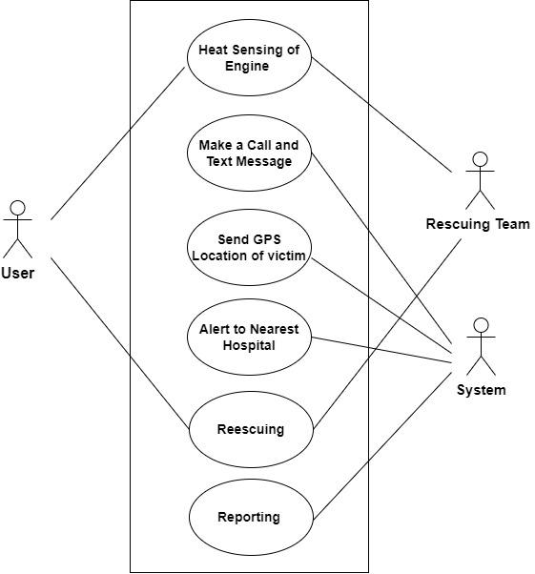

**Figure 3.1.1: Use Case Diagram**

### Activity Diagram

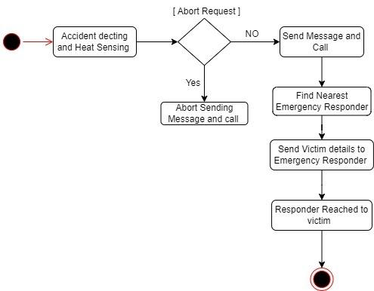

**Figure 3.1.2: Activity Diagram**

### Sequence Diagram

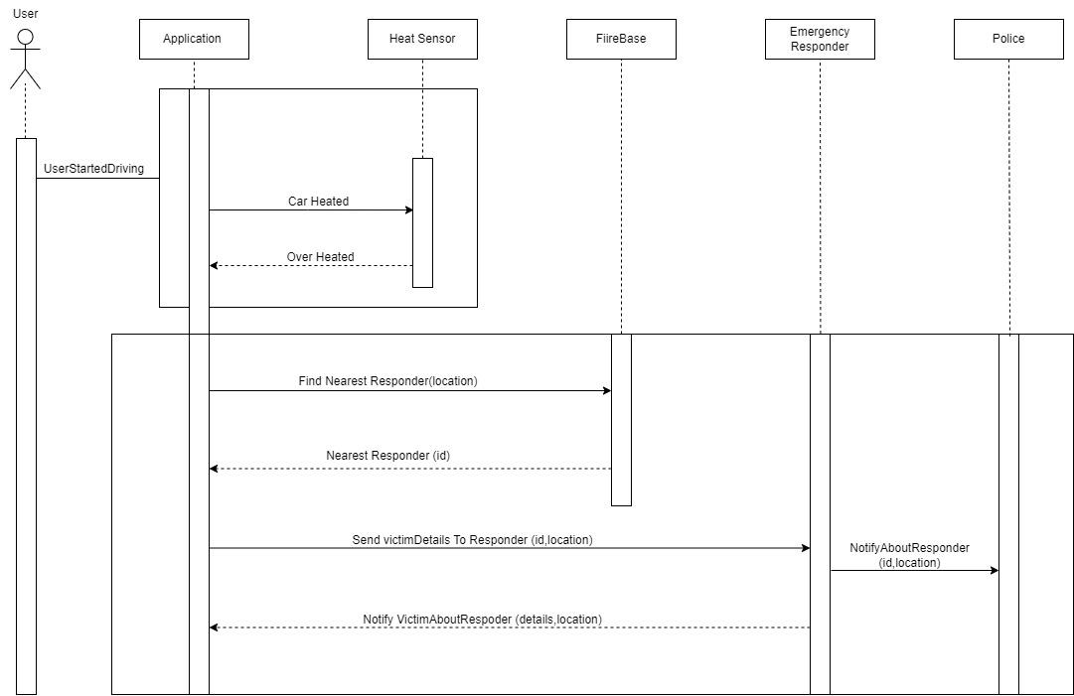

**Figure 3.1.3: Sequence Diagram**

### Dataflow Diagrams (DFDs)

* + 1. **Level 0 DFD**

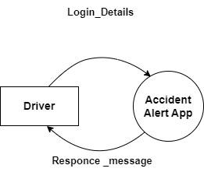

**Figure 3.2.1: Level 0 DFD**

### Level 1 DFD

### 

**Figure 3.2.2: Level 1 DFD**

### Level 2 DFD

### 

**Figure 3.2.3: Level 2 DFD**

### Technical Feasibility

* + 1. **Hardware Requirements**

**Table 3.3.1: Hardware Requirements**

| **Number** | **Description** |
| --- | --- |
| **1** | Operating System : Windows 7 (32/64 bit) and higher |
| **2** | Processor : Intel Pentium 4 or later |
| **3** | RAM : 2GB minimum 4 GB recommended |
| **4** | Arduino UNO |
| **5** | GSM Sim 900A |
| **6** | DHT 11 |
| **7** | Buzzer |
| **8** | 12V Adapter |
| **9** | Connecting Wires (Male to Female) |

### Software Requirements

**Table 3.3.2: Software Requirements**

| **Number** | **Description** | **Type** |
| --- | --- | --- |
| **1** | Operating System | Windows |
| **2** | IDE | Arduino |
| **3** | UI/UX Designing | Figma |

### Timeline/Gantt Chart

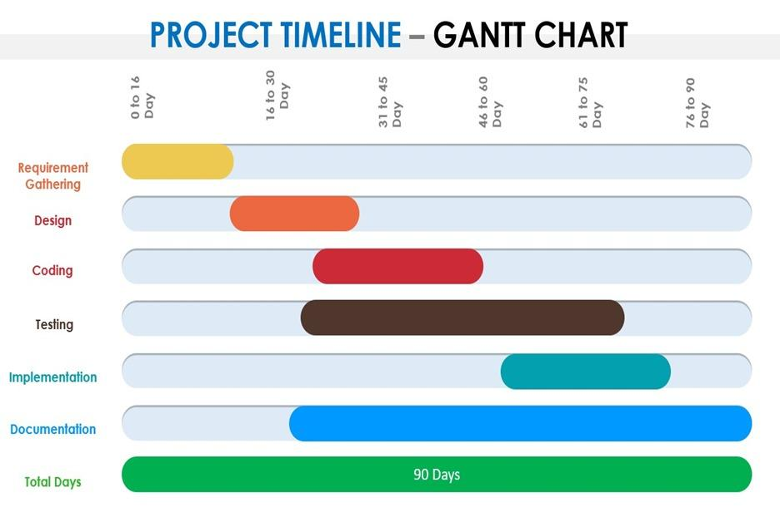

**Figure 3.4: Gantt Chart**

### Work Breakdown Structure (WBS) Chart

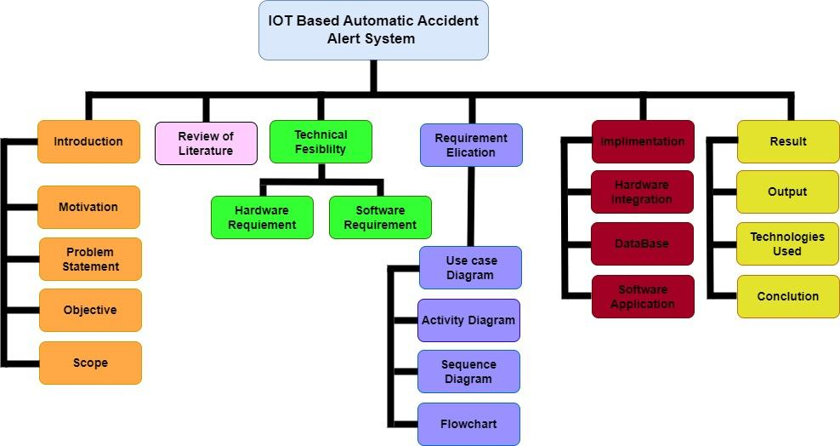

**Figure 3.5: WBS Chart**

## Chapter 4

**Report on Present Investigation**

### 4.1 Proposed System

### 4.1.1 Block Diagram Of Proposed System

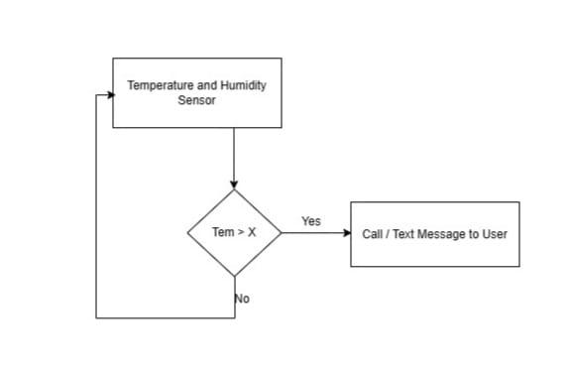

**Fig 4.1.1 Block Diagram Of Proposed System**

### Implementation

**4.2.1 Algorithm/Flowchart**

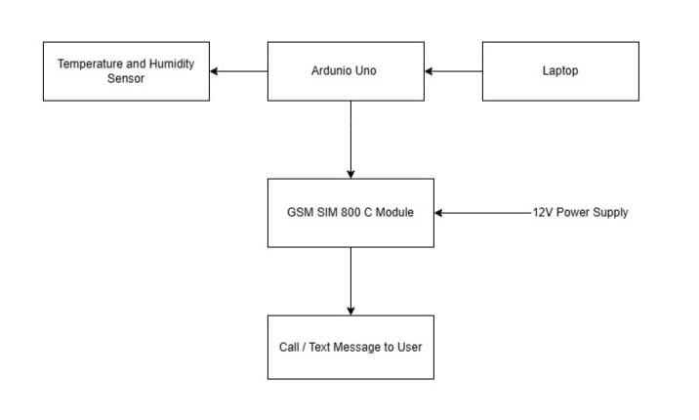

**Figure 4.2.1: Flowchart**

### 

### 4.2.2 Pseudo code

#include <SoftwareSerial.h>

#include "DHT.h"

#define DHTPIN 2

#define DHTTYPE DHT11

int buzzerPin = 8;

SoftwareSerial mySerial (9, 10);

DHT dht(DHTPIN, DHTTYPE);

void setup()

{

mySerial.begin(9600);

Serial.begin(9600);

Serial.println(F("DHTxx test!"));

delay(100);

pinMode(buzzerPin, OUTPUT);

dht.begin();

}

void loop()

{

delay(2000);

float t = dht.readTemperature();

Serial.println(t);

if(t>33.00){

buzzer();

call();

message();

}

}

void call(){

mySerial.println("ATD9923467195;");

delay(100);

mySerial.println("ATH");

}

void message(){

//Sets the GSH Module in Text Mode

mySerial.println("AT+CMGF=1");

delay(1000);

// Replace x with mobile number

mySerial.println("AT+CMGS=\"+91xxxxxxxxxx\"\r"); delay(1000);

// The SMS text you want to send

mySerial.println("OverHeat");

delay(100);

// ASCII code of CTRL+2 for saying the end of sms to the module

mySerial.println((char)26); delay(1000);

}

void buzzer(){

digitalWrite(buzzerPin, HIGH);

delay(10000);

digitalWrite(buzzerPin, LOW);

delay(5000);

}

### 4.2.3 Screenshots of the output with description

**4.2.3.1 Detection**

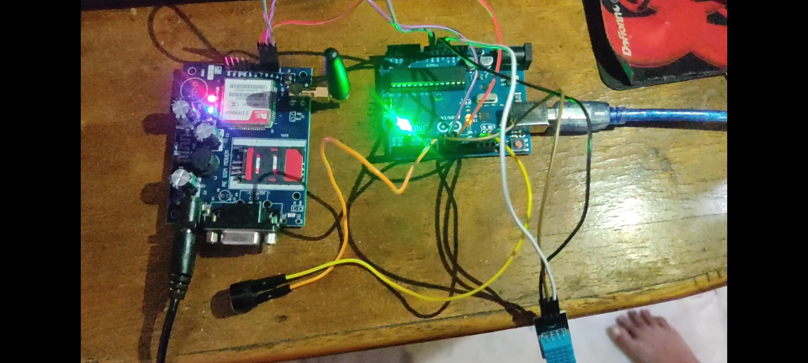

Fig 4.2.3.1 *Implementation of the Circuit*

**4.2.3.2 Alert Notification**



Fig 4.1.3.2 ***(b)***  *Message alert*

## Chapter 5

### Technologies Used

* C++
* DHT 11
* GSM Sim 900A
* Arduino UNO

## Chapter 6

**Results and Discussion**

An IoT-based Automatic Vehicle Accident Alert System is designed to swiftly detect and respond to vehicle accidents, offering benefits such as real-time accident detection, rapid alerts to emergency services, reduced response times, improved accuracy in differentiating accidents from false alarms, precise location tracking, valuable data for traffic safety analysis, heightened driver safety awareness, potential insurance incentives, and legal documentation. The system's effectiveness depends on the technology employed, integration with emergency services, network reliability, and regulatory considerations, and specific results would be contingent on individual implementations and evaluations.

## Chapter 7

**Conclusion**

In conclusion, an IoT-based Automatic Vehicle Accident Alert System has the potential to make significant strides in enhancing road safety and emergency response. By promptly detecting accidents and efficiently alerting emergency services, these systems can save lives and reduce the severity of injuries. Furthermore, they contribute to data-driven insights for traffic safety improvements. While the effectiveness of such systems can vary based on the technology and implementation, the overall impact is a move toward safer roads and a more effective emergency response infrastructure, ultimately leading to a reduction in accidents and their associated human and economic costs.

## References

1. Mohan, S., Rengarajan, N., & Saranya, A. (2016). IoT Based Accident Detection and Reporting System for Smart City. International Journal of Innovative Research in Computer and Communication Engineering, 4(8), 15910-15916.
2. Soni, P., & Sharma, S. K. (2017). IoT Based Vehicle Accident Detection and Notification System. International Journal of Advanced Research in Computer and Communication Engineering, 6(4), 118-121.
3. Azeez, S. A., Ananth, G. N., & Asokan, G. (2018). Real-Time Vehicle Accident Detection and Notification System Using IoT. International Journal of Innovative Technology and Exploring Engineering, 7(6), 1810-1812.
4. Hsu, C. W., Chen, T. H., & Huang, C. H. (2019). IoT-Based Smart Vehicle Accident Detection System. IEEE Transactions on Industrial Informatics, 15(5), 3115-3123.
5. Sivaramakrishnan, S., & Srinivasan, K. (2020). IoT-Enabled Vehicle Accident Detection and Alert System. Procedia Computer Science, 171, 122-129.
6. Wang, S., & Wang, X. (2021). A Comprehensive Review of IoT-Based Vehicle Accident Detection Systems. IEEE Access, 9, 12840-12853.
7. Albalushi, A. A., Al-Sultan, S., & Al-Muhtadi, J. (2022). Real-Time Vehicle Accident Detection System Using IoT and Cloud Computing. Sensors, 22(8), 2468.
8. Bello, O. A., & Mok, W. Y. (2022). Enhanced Vehicle Accident Detection and Notification System Using Machine Learning in IoT. Computers & Electrical Engineering, 99, 107270.
9. Garg, S., & Chhabra, P. (2023). IoT-Based Accident Detection and Notification System with Edge Computing. Journal of Ambient Intelligence and Humanized Computing, 1-13.
10. Li, X., Liu, B., Liu, K., Zeng, S. (2018). Vehicle Accident Detection and Monitoring System Using IoT and Cloud. IEEE Internet of Things Journal, 5(1), 24-32.
11. Elango, S., & Manogaran, G. (2019). IoT-Based Accident Detection and Notification System for Vehicles. Journal of King Saud University - Computer and Information Sciences.
12. Chaudhary, A., Meena, S., & Panwar, A. (2020). Real-Time Vehicle Accident Detection and Notification System Using IoT and Machine Learning. Proceedings of the International Conference on Data Science, Machine Learning & Applications.
13. Chong, W. K., Javadian, N., Alhamid, M. F., & Rahim, N. A. (2021). IoT-Enabled Smart Vehicles: A Survey on Technologies, Protocols, and Applications. Sensors, 21(18), 6055.
14. Wang, S., & Zhang, S. (2022). Smart Roads: A Comprehensive Survey on IoT-Based Road Accident Detection Systems. IEEE Transactions on Vehicular Technology, 71, 7246-7260
15. Sharma, A., & Singh, V. K. (2023). IoT-Enabled Vehicle Safety and Accident Detection System: A Review and Future Directions. Journal of Ambient Intelligence and Humanized Computing. (Forthcoming)

## Acknowledgment

We owe our deepest gratitude and regards towards the ones who offered their valuable guidance in the hour of need. We thank our guide **Mrs. Maya Patil** (Assistant Professor, Department of Information Technology, St. John College of Engineering and Management) for her guidance and precious insights. Her useful comments and feedbacks during the discussions we had and the encouragement to question every technical detail that we came across while partially completing this B.E. project helped us to a great extent.

We also take the opportunity to thank **Ms. Shraddha More** (B.E. Project Co-Ordinator) and **Dr.Arun Saxena** (Head of Department) who have always rendered their support and assistance in the best possible way.

We would also like to thank **Dr. G. V. Mulgund** (Principal, St. John College of Engineering and Management) and the **members of Aldel Education Trust** who have given us the background to conduct this B.E project.